Forest Explorers at Bentley
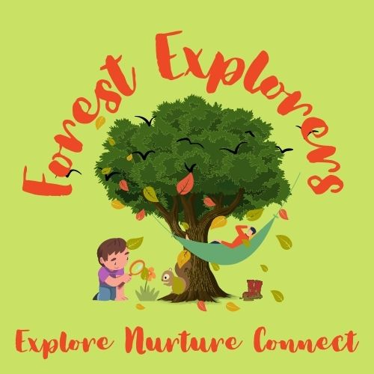
New for 2022, Forest Explorers takes place on Monday afternoons in our beautiful Bentley School woodland, with all children from Year 1-Year 6 attending for a half-term block of sessions (Year R have regular sessions in the woods at other times). Based on the Forest School ethos, our weekly child-led Forest Explorers sessions aim to provide children with opportunities to immerse themselves in nature, developing deep nature connectedness as well as independence, resilience, confidence and creativity. Thanks to recent research, we also know that time spent is nature is brilliant for our mental health and this is a very important reason why we are offering the children at Bentley these weekly sessions.
‘Forest School is an inspirational process that offers all learners regular opportunities to achieve and develop confidence and self-esteem through hands-on learning experiences in a woodland or natural environment with trees’.
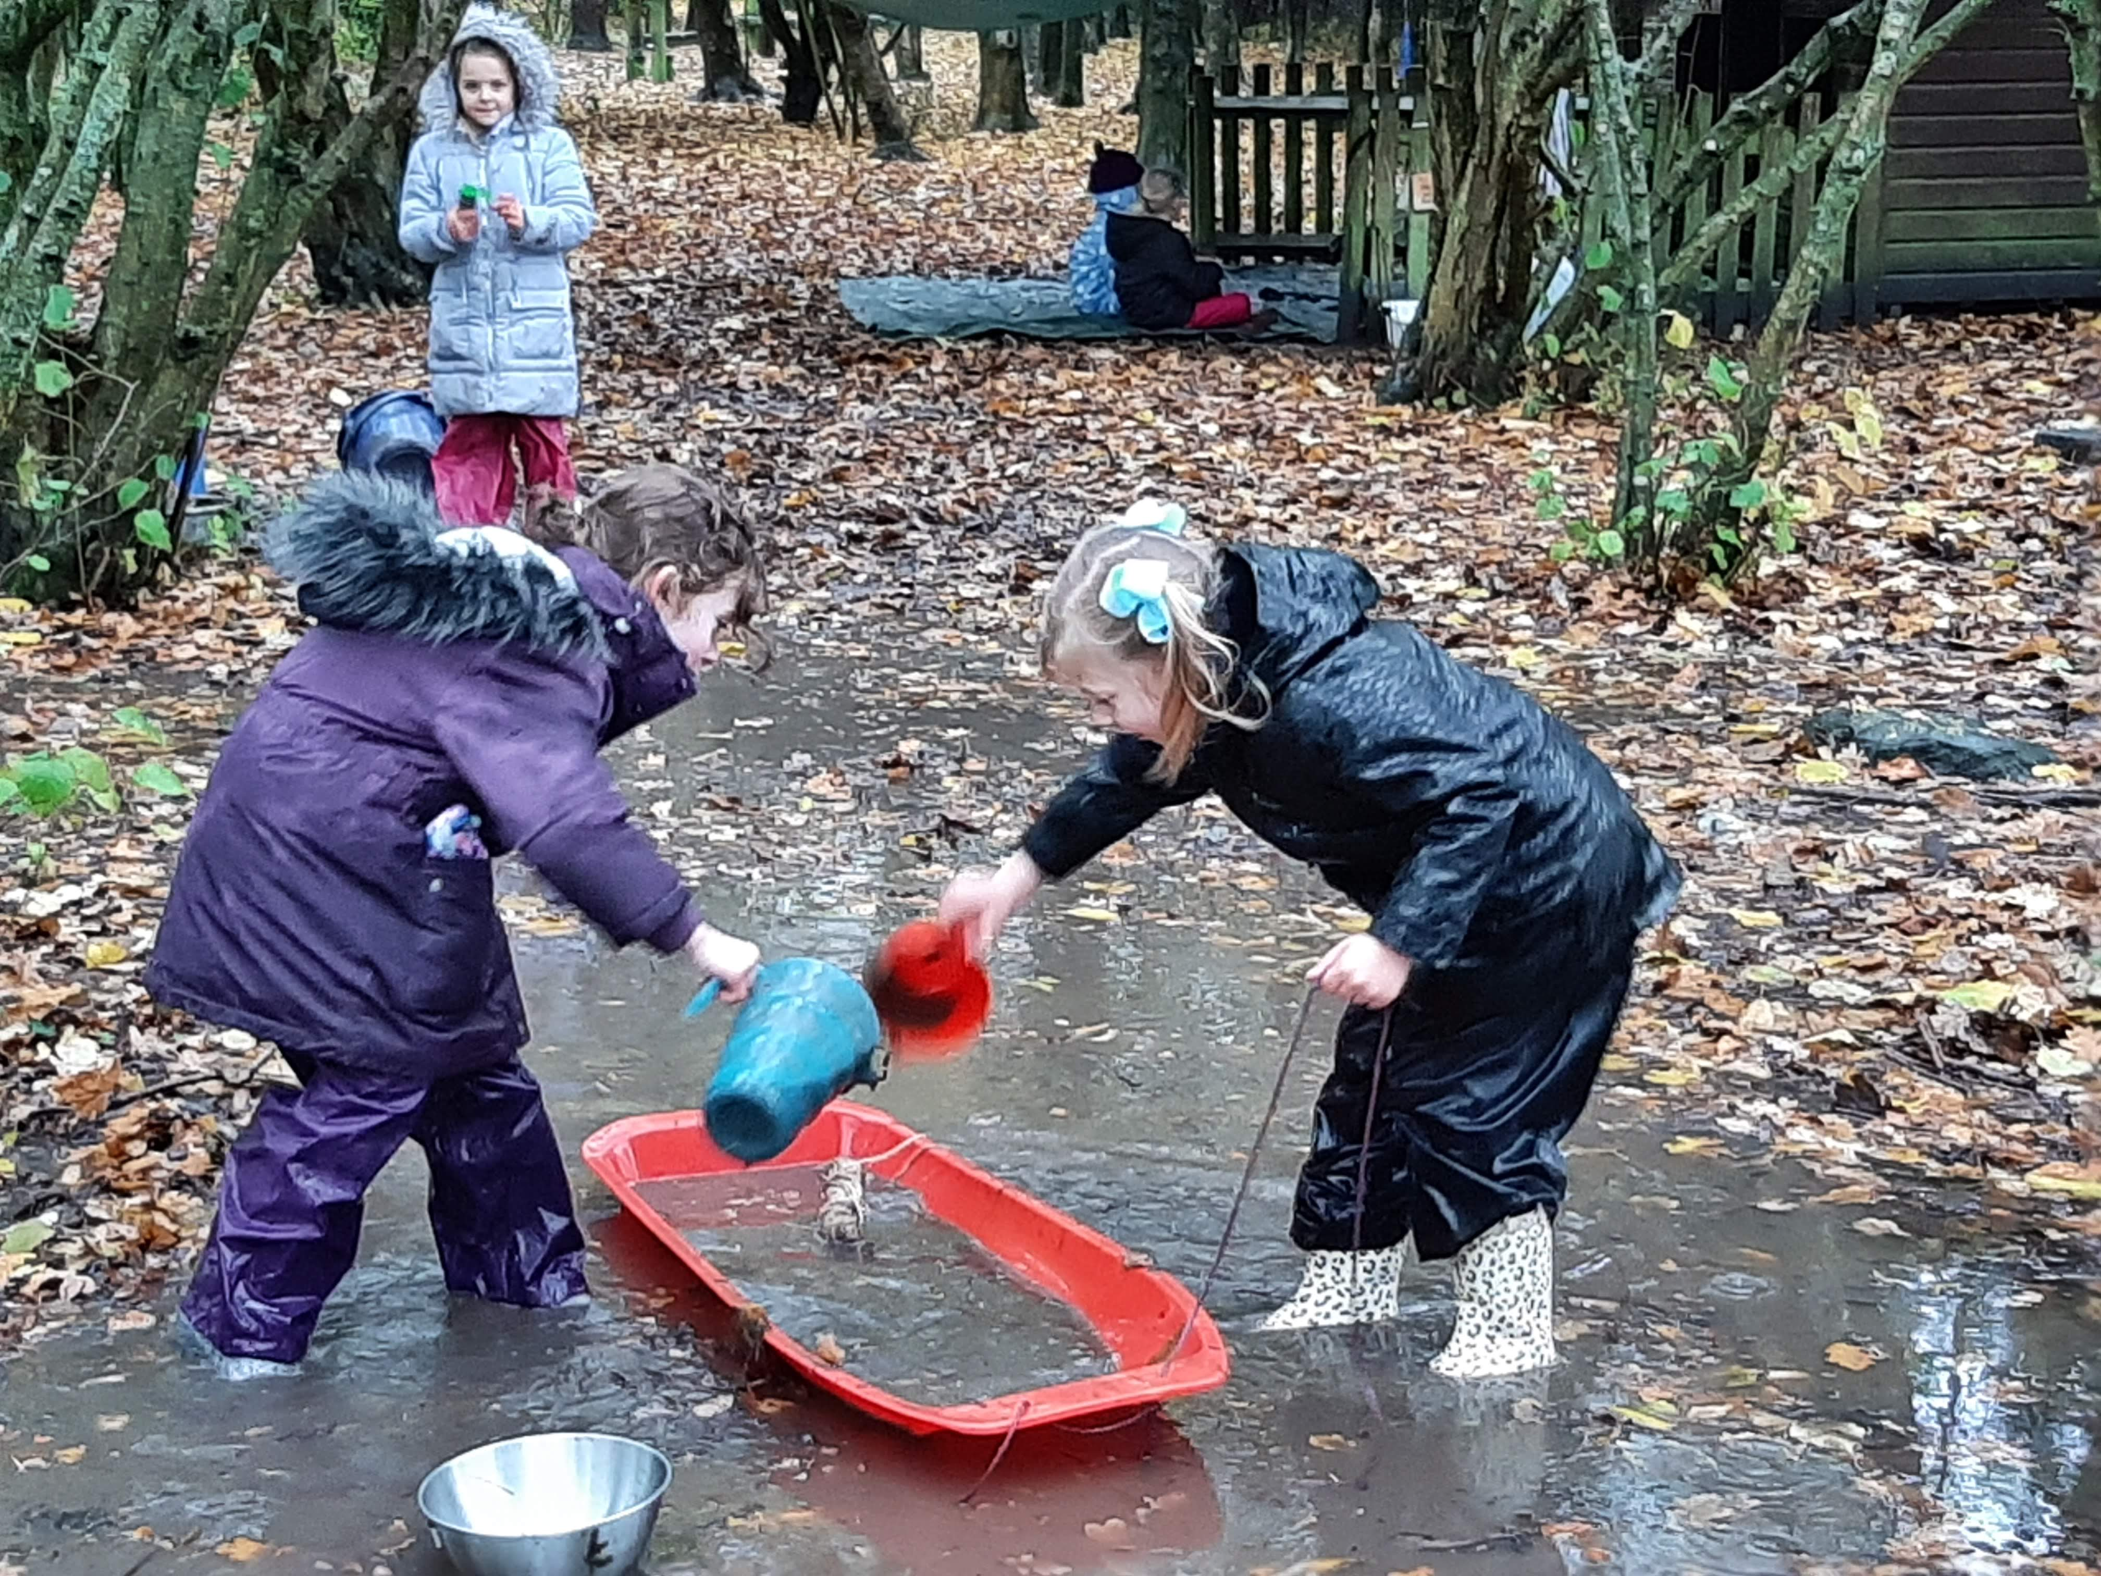
(Forest School Association)
Forest Explorers is led by Madame Jones, who is a qualified Level 3 Forest School Leader, assisted by volunteers from our school community. The Monday afternoon sessions run from 1-3pm with the children split into two groups, allowing each group one hour in the woods. Every session is themed e.g. birds, tools or fire and linked as much as possible to the season. We always start and finish the sessions as one group with time in the middle for self-directed play. This could involve muddy play, den building, bug hunting or a craft. During each half-term unit, we aim for all the children to experience using tools such as peelers and palm drills, as well as cooking on the fire.


