Pupil premium strategy statement – Bentley CE Primary School
This statement details our school’s use of pupil premium (and recovery premium) funding to help improve the attainment of our disadvantaged pupils.
It outlines our pupil premium strategy, how we intend to spend the funding in this academic year and the outcomes for disadvantaged pupils last academic year.

School overview
Detail | Data
Number of pupils in school | 183
Proportion (%) of pupil premium eligible pupils | Total = 12.6%  FSM = 8.7%  Service = 3.8%  LAC = 0%
Academic year/years that our current pupil premium strategy plan covers (3 year plans are recommended – you must still publish an updated statement each academic year) | 2025-2028
Date this statement was published | 8th December 2025
Date on which it will be reviewed | January 2026 - Review of objectives completed in blue  April 2026 - Review of objectives completed in purple  July 2026 - Review of objectives completed in green
Statement authorised by | Governing Body
Pupil premium lead | V Hallett
Governor / Trustee lead | J Phillips

Funding overview
Detail | Amount
Pupil premium funding allocation this academic year | 23,660
Recovery premium funding allocation this academic year
Recovery premium received in academic year 2023/24 cannot be carried forward beyond August 31, 2024.
Pupil premium funding carried forward from previous years (enter £0 if not applicable)
Total budget for this academic year | 23,660

Part A: Pupil premium strategy plan

Statement of intent
At Bentley CE Primary School, we use Pupil Premium funding to ensure that all disadvantaged and vulnerable pupils receive the highest-quality education and personalised support they need to flourish. Rooted in our Christian values of Love, Courage and Community, we are committed to nurturing every child so they can grow into confident, compassionate and socially responsible individuals. We recognise that disadvantaged pupils may face a range of academic, social, emotional or family-related barriers that can affect their learning and wellbeing.
Our aims are to:
- Remove barriers to learning created by individual circumstances, including academic needs, wellbeing needs, or challenges linked to home or background.
- Narrow the attainment gap between disadvantaged pupils and their peers, both within our school and nationally.
- Ensure all pupils become fluent, confident readers who can access the full breadth of the curriculum.
- Support families who may be experiencing vulnerability in order to improve outcomes for their children.
- Promote positive social and emotional wellbeing, helping pupils to develop resilience and confidence.
- Improve attendance and punctuality, ensuring all pupils are in school, on time and ready to learn every day.
Achieving our objectives
To meet these aims and overcome the identified barriers to learning, we will:
- Provide dedicated Pupil Premium champions who will monitor progress, ensure excellent provision, and facilitate strong communication between staff.
- Deliver targeted interventions and timely support to address gaps in learning, including small-group teaching and 1:1 tuition.
- Ensure that all pupils, including those eligible for Pupil Premium, can take part in enrichment opportunities such as sports, music, educational visits and residential trips.
- Offer high-quality pastoral support so pupils can confidently engage in learning both inside and outside the classroom.
- Work closely with families and external partners to promote good attendance, reduce persistent absence and support children to maintain regular routines.

Challenges
This details the key challenges to achievement that we have identified among our disadvantaged pupils.
Challenge number | Detail of challenge
1 | Attendance.  Analysis of attendance data last year indicates that attendance of children who are in receipt of pupil premium are more likely to be persistently absent compared with other demographic groups in Yr1-Yr6.
2 | Double disadvantage- A number of pupils on our PP register are also on our SEN register ( or SEMH) - needs are either cognition and learning- reading, writing and maths outcomes are below age related expectations
3 | Narrowing the attainment gap across reading, writing and maths, making sure high-quality inclusive teaching is in place. Low attainment for Pupil Premium children compared to non-Pupil Premium.
4 | Mental health and well being needs- many of the children on our PP register have difficulties in managing their emotions effectively and negotiating friendships.
5 | Lack of access to wider curriculum activities and cultural capital.
6 | In maths, there is a lower proportion of disadvantaged children achieving on their times table assessments, compared to their non-disadvantaged peers.
7 | Gaps in phonics knowledge
8 | Pupils in receipt of PP who are mobile (join mid-year with little or no prior schooling)
9 | Behaviour difficulties with a small group of children

Intended outcomes
This explains the outcomes we are aiming for by the end of our current strategy plan, and how we will measure whether they have been achieved.
Intended outcome | Success criteria
We want our disadvantaged children to make the most of their education by being present at school each day.  We want to increase in attendance percentages and a reduction in persistent absence. | There is a clear improvement for disadvantaged children’s attendance. The attendance % gap reduces, and individuals with challenging attendance shows a marked improvement. Reduction is persistent absence.
Good progress for disadvantaged pupils with SEN (double disadvantage) | Progress of children with SEN is never less than good.  Progress is measured through KTea tests and teacher assessments on INSIGHT
Increase in amount of PP children achieving the expected standard in reading, writing and maths and effective SEN provision enables children to make good progress | Data shows an increase in the number of children achieving EXS in RWM.  Monitoring by leaders shows a high level of pupil engagement in the school curriculum and progress being made. Through quality first teaching and bespoke interventions ensure that gaps  in learning are quickly identified and  acted upon. The impact being that we  narrow the gap between the attainment  of our groups shown in data. Children in receipt of the pupil premium with specific learning needs are well supported through effective provision.  Input from external professionals is accessed as required.
Read, Write Inc phonic programme is effectively used to ensure pupils make good progress in phonics leading to a greater number of those in receipt of the pupil premium to develop secure phonic skills | RWI tracking data at six weekly intervals shows children are making good progress through the sounds.  Increase in the amount of children passing the phonic check test at the end of Year 1 (and Year 2 resits).
Sustaining high levels of wellbeing for all pupils in our school, particularly our disadvantaged pupils. | Progress in ELSA targets  At least proportionate attendance at school led clubs  At least proportionate allocation of leadership roles in school (e.g. young governor)  Reduce levels of negative behaviour incidents as recorded on CPOMs  Attendance at Nest club to support friendships
To ensure a wide variety of enrichment  and outdoor opportunities are available  through the curriculum and wider extra curriculum. | High proportion of PP pupils access extracurricular opportunities.  Attendance for identified PP pupils improve.  Progress improves for identified pupils in  line with non PP and national.
PP pupils who join mid-year with limited prior schooling settle quickly, close learning gaps, and participate fully in school life. | Baseline completed and support plan in place within 2 weeks.  Accelerated progress from baseline in reading, writing and maths by end of first term.  Settled into routines within 4 weeks with reduced behavioural incidents.  Positive peer relationships formed within half a term.  Participation in at least one enrichment activity in first full term.
To improve the mental health and  wellbeing of all pupils so they are ready  and able to consistently engage with all  learning. | Identified pupils are able to access learning and personalised provision.  Attitudes to learning improve – less incidents of disengagement and/or poor behaviour.  The progress of identified pupils improves in line with all pupils and in line with national.
There is a clear understanding (amongst teachers and support staff) of ‘High Quality Inclusive Teaching’ based on Natalie Packer’s jigsaw model alongside the Ordinarily Available Provision document  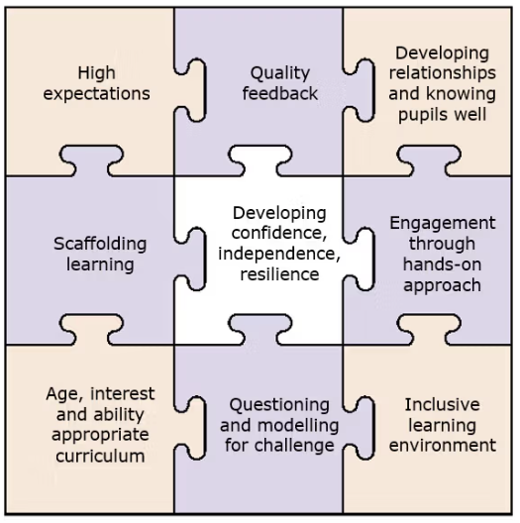 | There is a clear and shared understanding amongst all teaching and support staff of what High Quality Inclusive Teaching is.  HQIT teaching in all classrooms;  implementation of variation and  appropriate task design in all  classrooms, evidenced by learning  walks; formal and informal observations  by SLT, Maths Lead, English Lead and  Subject Leads.  Evidence of all areas within all KS1 and KS2 classrooms with a particular focus on ‘quality feedback’ using AfL strategies, e.g. flexible grouping.
Improved behaviour | Behaviour policy implemented  consistently across the whole school.  Advice from external agencies sought  and implemented in order to support  inclusive practise in all classes.  Reduced Red cards

Activity in this academic year
This details how we intend to spend our pupil premium (and recovery premium) funding this academic year to address the challenges listed above.

Teaching (for example, CPD, recruitment and retention)
Budgeted cost: £9000
Activity | Evidence that supports this approach | Challenge number(s) addressed
Bespoke Read, Write, Inc phonics training for specific staff, and additional resources. Led by SL  Opportunities to observe RWi in other settings to ensure consistency and HQT | EEF Pupil Premium Menu:  - – high quality teaching, assessment and curriculum that responds to the needs of pupils  - – professional development that supports the implementation of evidence based approaches  1.5 – technology and other resources to support high quality teaching and learning | 2 3 7 8
Professional development focused on effective support for a range of SEN needs through quality first teaching | EEF Pupil Premium Menu:  - – high quality teaching, assessment and curriculum that responds to the needs of pupils  - – professional development that supports the implementation of evidence based approaches | 2 3 6 8
Additional teaching & assessment materials & resources e.g. expand maths resources, phonics resources, KTEA assessments, Testbase | EEF Pupil Premium menu  1.1 - High quality teaching & assessment | 2 3 6 8
Senior Leadership time & Subject Leader time for dedicated curriculum development e.g. subject monitoring, developing assessment systems, additional professional development | EEF Pupil Premium menu:  1.1 - High quality curriculum  1.5 - Resources focussed on high quality teaching & learning | 2 3 6 8
Progress for double disadvantaged learners- continue to improve the quality of teaching through staff CPD using the OAP resources and undertaking training through PINs to increase understanding of what best practice looks like with the aim of continuing to reduce barriers to learning. | There is extensive evidence that the use of inclusive strate-gies improves outcomes for all.  https://www.gov.uk/government/publications/partner-ships-for-inclusion-of-neurodiversity-in-schools-pins/part-nerships-for-inclusion-of-neurodiversity-in-schools-pins-programme#evaluating-the-pins-programme  https://fish.hants.gov.uk/kb5/hampshire/directory/ad-vice.page?id=WXsvBiZG8DU | 2 3 6 8
Improving attendance through continuing clear attendance team meetings – governor, office staff and leadership team. Roll out approach to class teachers | Research clearly indicates that attendance levels of 95%+ lead to better educational outcomes. | 1 8
All staff to access  CPD on High Quality  Inclusive Teaching  -PDM programme  throughout year to  cover variation,  retrieval, flexible  grouping, assessment  for learning,  behaviour,  metacognition, self  regulation, all in line  with school  improvement plan  New staff  and ECT’s to access  highly effective induction and training. | EEF guide to Pupil Premium – tiered  approach – teaching is the top  priority, including CPD.  All teaching staff are confident in the  delivery and planning of their  curriculum which meets the needs of  all pupils, including those that are disadvantaged. This will impact upon attainment and progress for all pupils across school.  EEF guide to behaviour - Know and  understand your pupils and their influences - Pupil behaviour has multiple influences, some of which teachers can manage directly.  Understanding a pupil’s context will inform effective responses to misbehaviour. Every pupil should  have a supportive relationship with a member of school staff. | 2 3 6 8
Coaching to work  across the school  focusing on high  quality inclusive  teaching. | EEF guide to Pupil Premium – tiered  approach – teaching is the top  priority, including CPD. Coaching to  model high quality inclusive teaching  and promote self-reflection in all  teachers. | 2 3 6 8

Targeted academic support (for example, tutoring, one-to-one support, structured interventions)
Budgeted cost: £7000
Activity | Evidence that supports this approach | Challenge number(s) addressed
Additional phonics  sessions, run in line  with phonics scheme,  targeted at  disadvantaged pupils  who require further phonics support. | Targeted phonics interventions will  take place and these are proven to  be more effective when held for  regular sessions over a period up to  12 weeks. Phonics approaches have  a strong evidence base indicating a  positive impact on pupils, particularly from disadvantaged backgrounds. | 2 3 7 8
Subscriptions to targeted interventions - Language Link, RWI and software licences – TT Rockstars, White Rose maths | EEF Pupil Premium menu:  2.1 - Interventions to support language development, literacy & numeracy  2.2 - Activities & resources to meet the specific needs of disadvantaged pupils | 2 3 4 6 8
Structured interventions (CPD, delivery & resources) covering various areas of need | EEF Pupil Premium Menu:  2.1 - Interventions to support language development, literacy, and numeracy  2.2 - Specific needs of disadvantaged pupils with SEN | 2 3 4 6 8
ELSA  Additional social emotional learning sessions (ELSA) for disadvantaged children who need this support. | Evidence based research findings suggest the ELSA programme has a perceived positive impact on mul-tiple components of pupil wellbeing.  Hampshire Educational Psychology Service and ELSA network | 4
SALT and OT support for identified individuals  Increased screening of identified pupils to establish SALT or OT needs and plan a suitable provision. | Research shows that Benefits of Speech Therapy include a development of conversational skills that helps children in their interaction with others including adults and children their age.  Specific support is also highly recommended:  https://educationendowmentfoundation.org.uk/ed-ucation-evidence/guidance-reports/send | 2 3
Financial support for individuals to attend school led clubs | Building cultural capital may lead to increased engagement  https://d2tic4wvo1iusb.cloudfront.net/produc-tion/documents/guidance-for-teachers/pupil-pre-mium/guide_to_the_pupil_premium_-_evi-dence_brief.pdf?v=1726046314 | 5
Focus group time (pre-teaching / keeping up sessions) delivered by class teachers and LSAs | EEF Pupil Premium menu  2.4 - One to one and small group tuition | 2 3 4 6 8

Wider strategies (for example, related to attendance, behaviour, wellbeing)
Budgeted cost: £8660
Activity | Evidence that supports this approach | Challenge number(s) addressed
ELSA training, supervision, resources and delivery | EEF Pupil Premium Menu:  3.1 - Supporting pupils’ social, emotional & behavioural needs | 4
Well-being ambassadors  Training of children to be well-being ambassadors. | Wellbeing Ambassadors Programmes are designed to help with early prevention of mental health problems | 4
Family Support Worker to work with vulnerable families and improve parental engagement. | EEF (+3)  We define parental engagement as the involvement  of parents in supporting their children’s academic learning. It includes:  ● approaches and programmes which aim to develop parental skills such as literacy or IT skills;  ● general approaches which encourage parents to support their children with, for example reading or homework;  ● the involvement of parents in their children’s learning activities; and more intensive programmes for families in crisis. | 4 9
Positive phone calls home and personalised post cards sent home. | According to the EEF, Parental engagement has a positive impact on average of 4 months’ additional progress. Tailoring school communications to encourage positive dialogue about learning and providing parents with support for at-home learning. | 4 9
Staff training on  behaviour  management  approaches (in  particular for  children with  additional needs)  with the aim of  developing our  school ethos and  improving behaviour across the school.  Working with  external  behaviour  specialists on INSET | EEF (+4)  Social and Emotional Learning (SEL)–  interventions which target social and emotional learning seek to improve pupil’s interaction with others and self-management of emotions, rather  than focusing directly on the academic or cognitive elements of learning. SEL interventions might focus on the ways in which students work with  (and alongside) their peers, teachers, family and community. These include: specialised programmes which are targeted at students with particular social or emotional needs. | 9
Cost of one school-run club per term covered by school for FSM PP children | EEF Pupil Premium Menu:  3.3 - Extra-curricular activities | 5
Subsidising of school trips (including residential trips) for FSM PP children | EEF Pupil Premium Menu:  3.3 - Extra-curricular activities | 5
Subsidising or covering full cost of before and after school wraparound care FSM PP | EEF Pupil Premium Menu:  3.5 – Breakfast clubs and meal provision  Social and emotional learning approaches have  shown to have a positive impact on academic  progress. Improving social interaction between  pupils helps support disadvantaged pupils to  engage in healthy relationships and navigate  social-emotional self-regulation. Evidence also  suggests that participating in physical activity is  likely to have health and social benefits. | 5
Lunchtime Support through: Nest Club play games Gardening Club | The aim is to provide stimulating environments and activities or develop additional personal and social skills. | 4 5
CPOMs subscription to identify behaviour needs, patterns & trends, using tracking to plan and implement appropriate support | EEF Pupil Premium Menu:  3.1 - Supporting children’s social, emotional & behavioural needs  Partial payment | 4 9
Forest school is offered to all children and an SEMH group and SEND group. | Evidence suggests forest learning provides children with: confidence (freedom, time and space to learn and demonstrate independence), social skills (increased awareness of the consequences of their actions on peers through team activities such as sharing tools and participating in play), communication (language development prompted by children’s sensory experiences), motivation (keenness to participate and the ability to concentrate over longer periods of time), physical skills (characterised by the development of physical stamina and gross and fine motor skills), knowledge and understanding (developing an interest in the natural surroundings and respect for the environment). | 4 5 9

Total budgeted cost: £23,660

Part B: Review of the previous academic year

Outcomes for disadvantaged pupils
Whole school data 2023-2024
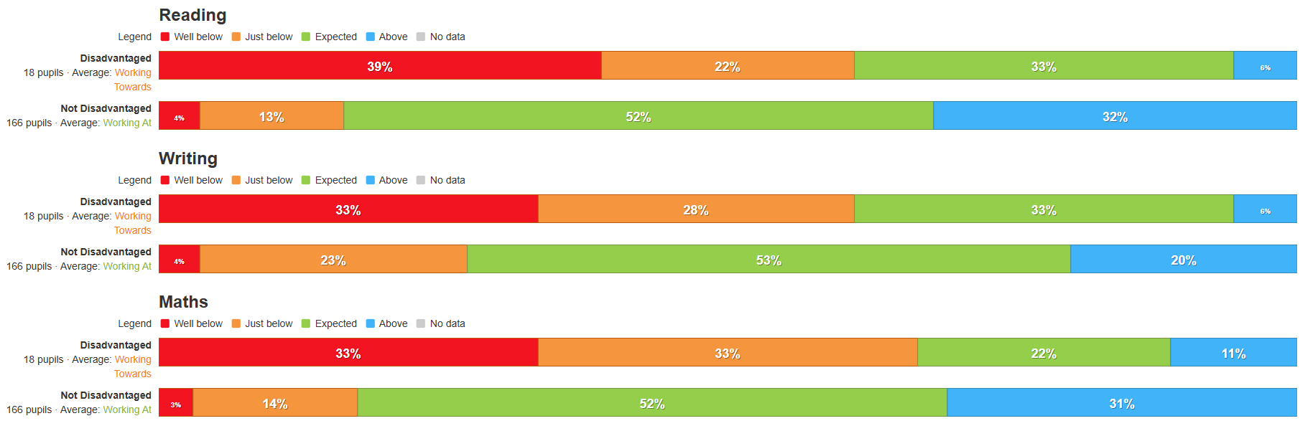

Year 6

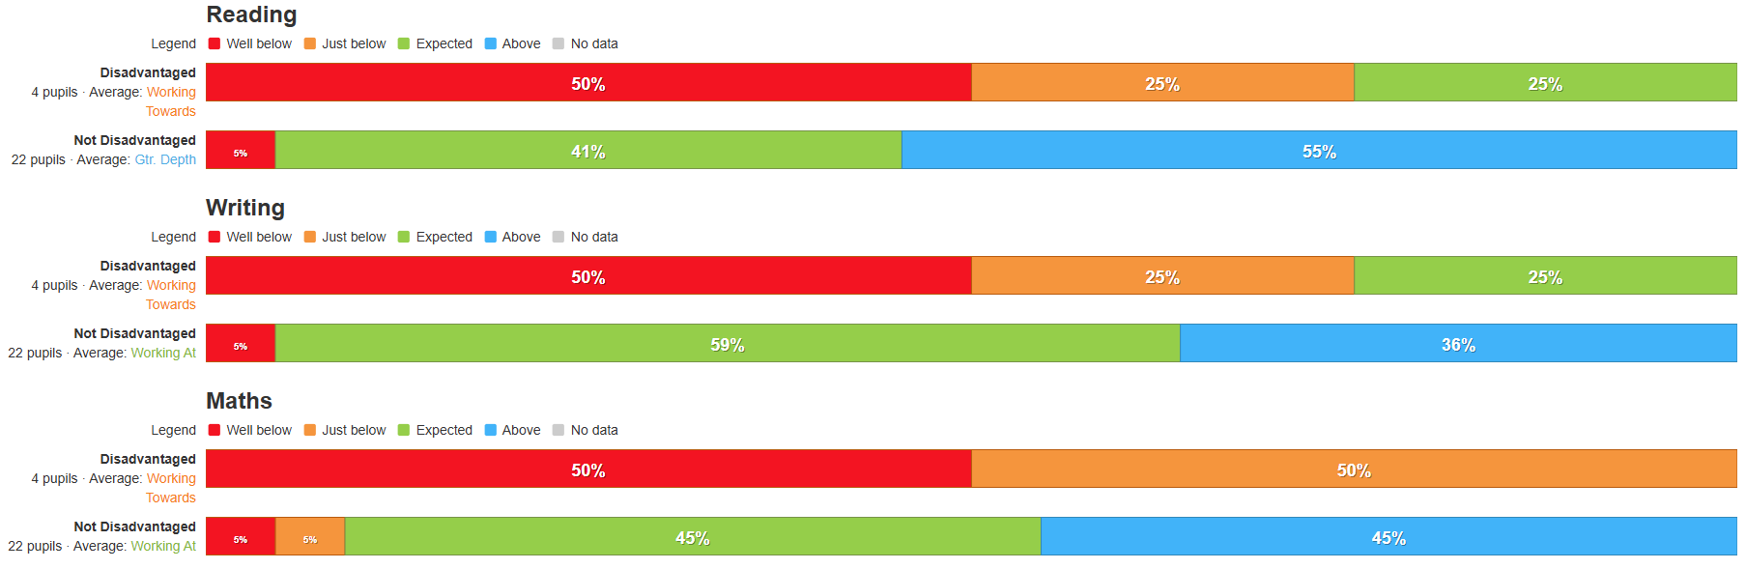

Year 2
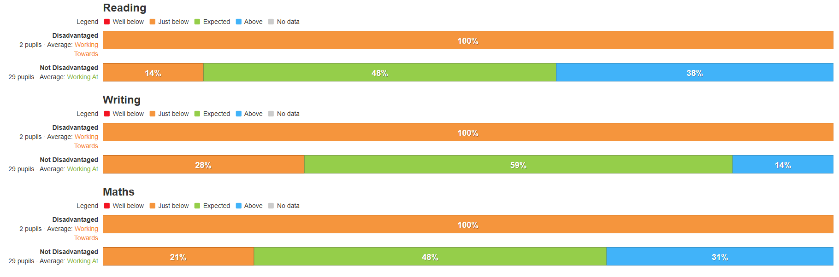

We use this data to identify trends and spot patterns. As a small school, our pupil premium numbers are low. For example in Year 6 last year there were 4 children. One of whom was also on SEN register with EHCP. In addition to this, two of the PP children were also GRT and did not sit the SATs tests as they were travelling. In Year 2 there were only two children on the register. One of which is also a GRT child, who was travelling for the summer term.
Overall, children in receipt of pupil premium achieved either in-line or a slightly lower level of attainment than their non-pupil premium peers in reading. But children in receipt of pupil premium attained lower in writing and maths compared to non-premium children.

Overall attendance in 2024/2025
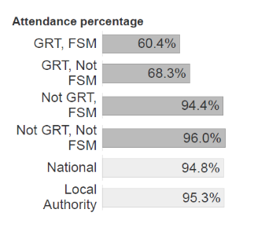

- End of 2024-2025 – 64.9% GRT, 95.9% non GRT, 92.8% whole school.
- Current picture – 84.7% GRT, 96.4 Non GRT, 95.2% whole school

We used pupil premium funding to provide wellbeing support for all pupils, and targeted interventions where required. Support was offered to families through funding for school uniform and towards the cost of events such as trips, visitors and after/before school clubs.
For the whole school an improvement in attendance was seen last year and absent
rates are once again below national. Our Family Support Workers and Leadership
Team worked closely with key families to support two pupils with Emotionally Based School Avoidance (EBSA). However our group data shows that attendance and punctuality for our Pupil Premium children is significantly lower than their peers.

Most children in receipt of the pupil premium for FSM have attended a school club each term free of charge and have had trips and residential visits subsidised. The impact of this has led to an improvement in their social and emotional health due to more positive relationships being formed, ultimately impacting positively on their mental health. When appropriate, FSM and Service children have benefitted from ELSA sessions leading to a positive impact on mental health.

Externally provided programmes
Please include the names of any non-DfE programmes that you used your pupil premium (or recovery premium) to fund in the previous academic year.
Programme | Provider
Read, Write Inc Phonics | Ruth Miskin (RWI phonics programme)
Language Link (SALT programme) | Language Link
Times Tables Rockstars | TT Rockstars
INSIGHT assessment | Equin Ltd
CPOMs | Raptor Technologies
Toe by Toe (reading intervention) | Toe by Toe

