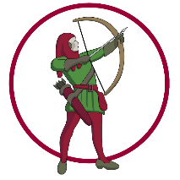
Bentley CE Primary School

EYFS
Intent

At Bentley, we are ambitious for every child and aim to build strong foundations from the very start in EYFS. Our school is rooted in Christian values of love, courage, and community, reflecting God’s deep love for us, which we weave into everyday life.
We provide a rich, engaging curriculum that inspires children to learn and teachers to teach. High-quality teaching in a nurturing, inclusive environment ensures all children, regardless of background or ability, can develop their full potential. We value individuality and celebrate differences.
Each year, we consider children’s unique starting points to shape a play-based EYFS curriculum that develops essential skills, knowledge, and understanding, preparing them for the next stage of their education. Children with additional needs, including SEND, receive tailored support to help them succeed.
Daily learning includes child-initiated and adult-led activities in carefully designed indoor and outdoor environments. We work closely with parents and carers to nurture happy, independent learners. Our aim is for all children to make strong progress, achieve the Early Learning Goals, and transition confidently into KS1.

Implementation

We achieve our curriculum intent by providing high quality teaching and learning opportunities for all children. The curriculum is delivered by following the Statutory EYFS Framework Sept 2021 and supported by the Development Matters non-statutory curriculum guidance July 2021
Our Early Years curriculum at Bentley is planned to provide teaching and learning opportunities activities across the seven areas of learning.
The Prime Areas:
- Communication and Language
- Personal, Social and Emotional Development
- Physical Development
The Specific Areas:
- Literacy
- Mathematics
- Understanding the World
- Expressive Arts and Design
We have a curriculum that is child-centred and that is based upon enrichment experiences and topics which engage the children. We take time to get to know children’s interests and regularly develop existing topics to respond to the children’s changing needs and interests. Throughout the year, we work towards our aspirations as final outcomes to our learning journeys.
All areas of the EYFS curriculum are followed and planned for to ensure there is a broad, balanced and progressive learning environment and curriculum.
Our environment incorporates continuous and enhanced provision. We believe that access to continuous provision activities provides the children with vital opportunities to embed prior learning and independently practise skills previously taught. Through initiating their own play in continuous provision the children can be creative in their approach to their learning and develop vital communication and language skills as they collaborate, share and take turns.
Enhanced provision activities are more focussed, often topic based, and designed to be stimulating and engaging. They allow children to develop particular skills essential to their development.
We aim to ensure that these areas are always stimulating and exciting and that, importantly, they are accessible to all children, regardless of where they are on their learning journey. The environments are developed to encourage challenge and allow them to access the curriculum independently and confidently with the necessary level of support and challenge.
We ensure our continuous and enhanced provision supports the development of the children’s Characteristics of Effective Learning. These are:
- Playing and Exploring – children investigate and experience things, and have a go;
- Active Learning – children concentrate and keep on trying if they encounter difficulties, and enjoy achievements;
- Creating and Thinking Critically – children have and develop their own ideas, make links between ideas and develop strategies for doing things.
These elements underpin how we reflect on each child’s development and adjust our practice accordingly. Supporting children in the development of their individual learning behaviours and observing the context of their play is essential to identifying next steps for learning.

Our Curriculum Aspirations
Our aspirations set out what we hope all children will experience, develop, and achieve during their Reception year, ensuring they feel safe, supported, and excited about learning. They guide our teaching, planning, and support, ensuring that every child has the opportunity to grow academically, socially, and emotionally. By setting aspirations, we create high expectations for all children and ensure our approach is consistent, purposeful, and focused on their well-being and development.
Our aspirations are designed to integrate the seven areas of learning and development in EYFS (Personal, Social & Emotional Development, Physical Development, Communication & Language, Understanding the World, Expressive Arts & Design, Mathematics, and Literacy) into meaningful, project-based experiences. Each aspiration is a practical goal that combines skills, knowledge, and attitudes through hands-on activities and collaboration.

Aspiration 1: Retell a Favourite Story to Year 6 Buddies
Purpose: Develop communication, creativity, and confidence through storytelling.
Overview:
- Children select a story, adapt it, and retell it using expressive arts (drama, dance, puppetry).
- Activities include making invitations, creating props, writing simple scripts, and performing.
- Links to EYFS areas: Literacy (story maps, invitations), Expressive Arts & Design (puppets, music), PSED (relationships, resilience), Maths (numbered seats, ticketing), UTW (local traditions).
Aspiration 2: Create Fairground Games for Year 1
Purpose: Foster problem-solving, teamwork, and mathematical reasoning.
Overview:
- Children design and build simple games, write rules, and explain them to others.
- Activities include exploring traditional games, creating signs, and calculating scores.
- Links to EYFS areas: Maths (counting, addition), Communication & Language (explaining rules), PSED (turn-taking), Physical Development (coordination), Expressive Arts & Design (game boards).

Aspiration 3: Create and Share a Picnic
Purpose: Promote healthy living, collaboration, and practical life skills.
Overview:
- Children plan a menu, grow food, prepare dishes, and share a picnic.
- Activities include measuring ingredients, following recipes, and discussing hygiene.
- Links to EYFS areas: Understanding the World (growing plants), Maths (measuring), Physical Development (safe handling), PSED (collaboration), Literacy (shopping lists, recipes).
Aspiration 4: Create a Page for Our RE Floor Book and Share with Year 1 Teacher
Purpose: Encourage reflection, respect for diversity, and creative expression through religious education.
Overview:
- Children create a page for the RE floor book using photographs, drawings, and artwork.
- Activities include listening to and acting out Bible stories, exploring traditions like Shabbat, and discussing family and faith.
- Links to EYFS areas: Communication & Language (sharing experiences), Literacy (writing labels, captions), Expressive Arts & Design (collage, painting), PSED (respect for differences), Understanding the World (learning about religions), Maths (page numbering, sorting).
Together, these aspirations provide a holistic approach to learning, ensuring coverage of all EYFS areas while fostering creativity, independence, and community engagement.

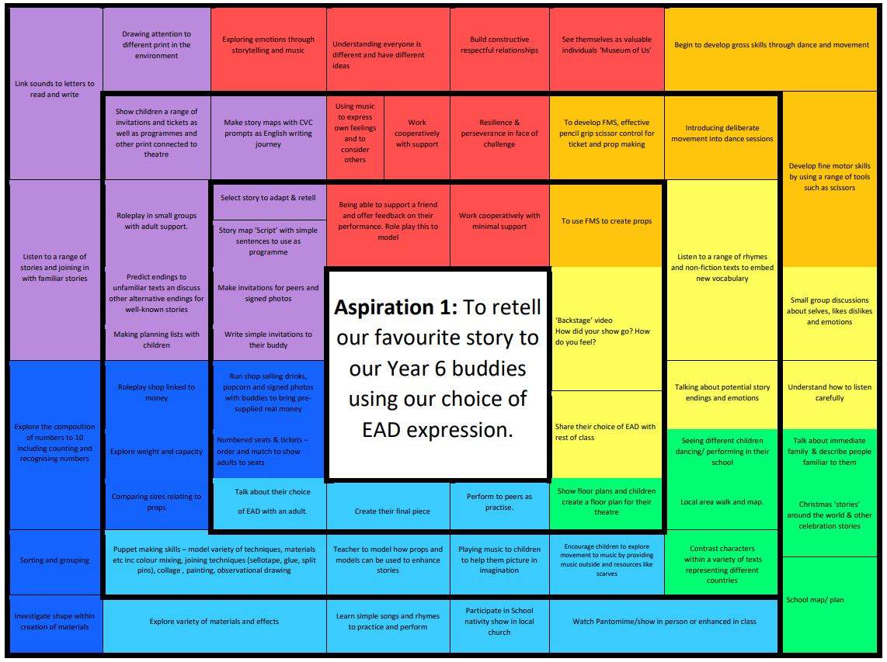
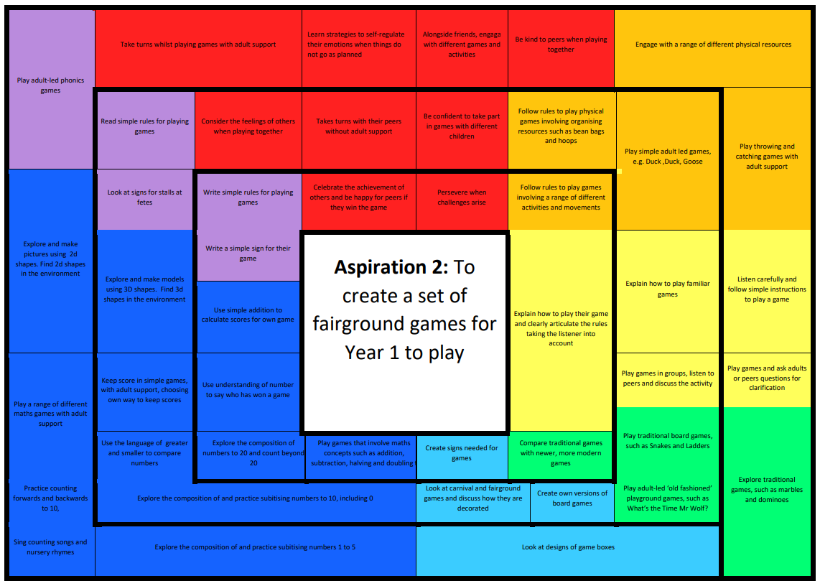
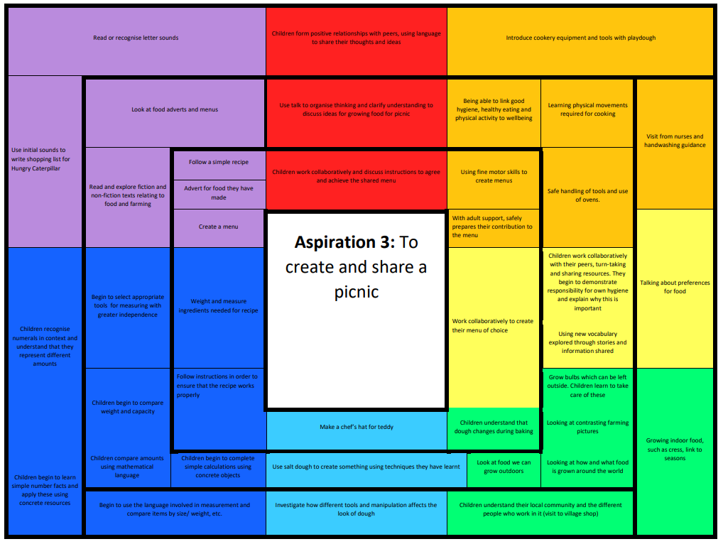
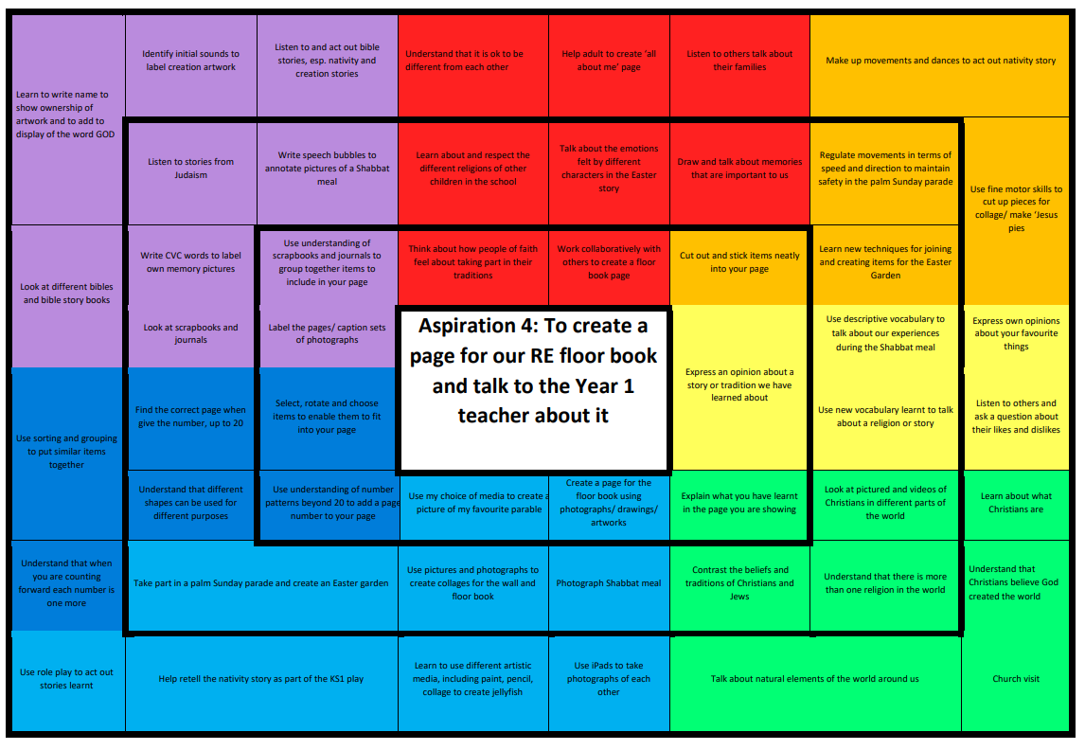
Reading and Phonics
At Bentley, we use a systematic synthetic phonics programme called Read Write Inc (RWI) to teach children to read. Phonic sounds are introduced in a fun and engaging way during our children’s first term in Early Years. Sessions are taught daily and children work in small groups according to their confidence and competence. The groups are reassessed and re-organised on a regular basis in order to match the pace and progression of each child. The overarching aim of the RWI programme is to teach pupils to:
- Segment words into their constituent phonemes in order to spell words.
- Apply the skill of blending to read real and monster (made up) words.
- Learn that blending and segmenting are a reversible process and help with both reading and spelling.
- Read high frequency words (red words) that do not conform to the regular phonic patterns.
- Read texts and words that are within their phonic capabilities as early as possible.
- Decode texts effortlessly so that they can focus on using reading to learn; comprehension skills.
- Spell accurately using the sounds that they have already been taught.
All children take two reading books home a week which are matched to the phonic sounds they have been taught and are currently learning.

Writing
To help children become confident early writers by building strong foundations in language, mark‑making, handwriting, phonics and purposeful writing based on the EYFS curriculum and Writing Framework 2025

Early Mark‑Making
- Children explore marks from the moment they join us.
- We provide a wide range of tools (chalk, pens, paint, sand, natural materials) across indoor and outdoor areas.
- Practitioners celebrate all marks as a form of communication.
Spoken Language First
- Writing begins with talking. Children rehearse ideas aloud before writing.
- Adults model vocabulary, sentences, storytelling and explanations.
- High‑quality books, rhymes and role‑play enrich children’s language.
Handwriting and Motor Skills
- Daily opportunities develop hand strength and coordination (playdough, threading, climbing, construction).
- When ready, children are taught how to hold a pencil and form letters correctly.
- Handwriting is introduced gradually and practised regularly.
Phonics and Early Spelling
- Writing links closely with our phonics programme, Read Write Inc
- Children learn to hear sounds in words and record them using letters.
- Early spelling focuses on phonetic attempts, building accuracy over time.
Purposeful Writing Opportunities
- Writing is embedded across the environment: lists, signs, labels, cards, messages, role‑play writing.
- Adults model writing throughout the day.
- Children’s writing is displayed and celebrated.
Progression
Children typically move through:
- Mark‑making → Letter‑like shapes → Recognisable letters → Simple words → Short phrases or sentences
- Progress is individual and non‑linear; adults support children at their own developmental stage.

Mathematics
Mathematics in Bentley is taught through practical, engaging, and child-centred whole class sessions. We follow the White Rose Maths scheme, which provides a clear, progressive framework for developing mathematical understanding from the earliest stages. Within this framework, we use a ‘Number of the Week’ approach to give children focused, in-depth experience of a single number. This is supported by the BBC Numberblocks program and a range of hands-on resources to inspire, motivate, and make learning accessible and enjoyable. We follow a teaching-for-mastery approach with a strong focus on developing secure early number sense. Guided by NCETM materials, we give children rich opportunities to “see the maths” through subitising, comparison, and exploring the composition of number. Using clear representations, precise mathematical language, and small-step progression, we ensure understanding is deep and secure. Through purposeful play and meaningful mathematical talk, children build confidence, flexibility, and a strong foundation for future learning.
During whole-class sessions, children might explore numbers through counting objects, using numicon or cubes to build numbers, matching quantities to numerals, and using everyday objects for simple addition and subtraction. For example, children might sort toy animals into groups, share fruit between teddies, or identify shapes in the classroom environment. Songs, games, and interactive stories are also used to reinforce number recognition and mathematical language, making learning fun and memorable.
In addition to these structured sessions, our enhanced provision provides continuous opportunities to practise and consolidate mathematical skills in a play-based context. Children might:
- Measure ingredients in a baking activity, exploring weight and volume.
- Build towers or patterns with blocks, recognising shapes, sizes, and sequencing.
- Use the sand or water trays to explore capacity and volume.
- Play shop or role-play games, using coins and counting money to develop early numeracy.
- Sort and classify objects by colour, size, or shape, developing their understanding of sets and categories.
A key focus of our EYFS maths curriculum is the development of reasoning skills. Children are encouraged to explain their thinking, justify their choices, compare quantities, and find multiple ways to solve problems. Staff use targeted questioning such as “How do you know?” or “Can you show me another way?” to scaffold children’s reasoning and extend their thinking. This ensures children not only acquire essential numeracy skills but also build a strong foundation in logical thinking, problem-solving, and confidence with numbers, preparing them for future learning in Key Stage 1 and beyond.

Overview

Area | Autumn 1 | Autumn 2 | Spring 1 | Spring 2 | Summer 1 | Summer 2
General Themes NB: These themes may be adapted at various points to allow for children’s interests | Its Good to be me  Being a Caterpillar  Curly’s Tour  Elmer  Me  My school  Who is God?  Dinosaurs - Mary Anning?  The Very Hungry Caterpillar | All about me!  Me and how I have changed  Why do Christians perform nativity plays at Christmas?  The body  Games  Stick Man  Christmas Nativity | Terrific Tales & Games  Traditional Tales  Familiar tales  Family favourites  Nursery Rhymes  Chinese New Year  Shabbat | Spring to Life!  Down on the Farm  Plants  Minibeasts  Life cycles (chicks, frogs, butterflies)  Signs of Spring  Easter – new life, eggs and chicks | People Who Help Us  Police  Fire /Ambulance service  Vets  Doctors  Dentists  Road Safety  Emergency Vehicles  Farmers  Superheroes | What an adventure!  Travel - World travel  Around the world  Space  Materials and magnets  Fairs  Off on holiday
Special Events  Wow Start Celebration Finish | Harvest Time  Introducing buddies – buddy story time  Introducing Travelling Toy  Trip to Theatre  Apple Picking | Trip to St Marys church | Farnham Museum – toys  Local Walk  Performance | Visit to a garden Centre | Trip to Pizza Express  Retelling a favourite story to Y6 | Teddy Bear picnic with Dottie Tots  Fairground games with Y1
Parent Engagement | Staggered Starts Home visits Parent’s Evening – parent’s voice  WOW moments on Seesaw Walk and Talk board daily  Harvest Festival | Nativity  WOW moments on Seesaw Walk and Talk board daily  Christingle | WOW moments on Seesaw Walk and Talk board daily  Music Worship for parents | Parent’s Evening – parent’s voice  WOW moments on Seesaw  Walk and Talk board daily  Year R cake Sale  Class Worship to parents | WOW moments on Seesaw Walk and Talk board daily | WOW moments on Seesaw Walk and Talk board daily
Possible Texts  And  ‘Old Favourites’ | Creation Stories  Once there were Giants  Harry and bucketful of dinosaurs go to school Peepo  Elmer  Gigantosaurus  Mad about dinosaurs Dinosaur Roar Bumpus | Mog’s Christmas Calamity  The Christmas Story  Stick Man  When I grow up  It like myself?  Leo the late bloomer  Just like me | The Jolly Postman Goldilocks  Gingerbread Man  Jack and the beanstalk  Little Red Riding Hood Hansel & Gretel  Cinderella | The Easter Story  The runaway pancake  The odd egg  Billy’s Beetle  The Tiny Seed  Jasper’s Beanstalk  Dinosaur Rumpus  How to grow a dinosaur Farmer Duck  What the ladybird heard Farmyard Hullabaloo | The Selfish Crocodile  Mog’s Christmas Calamity Rumpus at the vet  Zog and the flying doctors Cops and Robbers  Non-Fiction books related to people who help us | Giraffes can’t dance  The Ugly Five  Barry the Fish with Fingers  Rainbow Fish  The Way back Home  Man on the Moon  Whatever Next  Q Pootle 5  Aliens love underpants
Maths | Match, Sort, Compare  Talk about measures and patterns | Its me 123  Circles and triangles  12345  Shapes with 4 sides | Alive in 5  Mass and Capacity  Growing 678  Length, height & time | Length, height & time  Building 9 10  Explore 3D shapes | To 20 and beyond  How many now?  Manipulate, compose and decompose  Sharing and grouping | Sharing and grouping  Visualise build and map  Make connections  Consolidation
Aspiration 1 | - Understanding everyone is different and have different ideas  - See themselves as valuable individuals ‘Museum of Us’  - Talk about immediate family and describe people familiar to them  - Small group discussions about selves, likes, dislikes, and emotions  - Build constructive respectful relationships  - Begin to develop gross motor skills through dance and movement  - Learn simple songs and rhymes to practise and perform.  - Work cooperatively with support  - Listen to a range of stories and joining in with familiar stories  - Explore a variety of materials and effects  - School map/plan  - Link sounds to letters to read and write  - Develop FMS by using a range of tools e.g. scissors  - Sorting and grouping | - Watch pantomime / show in person  - Begin to develop gross motor skills through dance and movement  - Exploring emotions through story telling and music  - Investigate shape within the creation of materials  - Drawing attention to different print in the environment  - Christmas stories from around the world  - Investigate shape within creation of materials  - School map/plan  - Link sounds to letters to read and write  - Show children a range of invitations and tickets and programmes linked to theatre  - Develop FMS, effective pencil grip, scissor control for ticket and prop making  - Understand how to listen carefully  - Explore the composition of numbers to 10 including counting and recognising numbers  - Participate in school nativity | - Encourage children to explore movement to music by providing music outside and resources like scarves  - Make story with CVC prompts as English writing journey  - Contrast characters within a variety of texts representing different countries  - Listen to a range of stories and joining in with familiar stories  - Select a story to adapt and retell  - Role play in small groups with adults support  - Show children a range of invitations and tickets and programmes linked to theatre  - Introduce deliberate movement into dance sessions  - Listen to music and express own feelings  - Local area walk and map  - Role play shop linked to money  - Explore weight and capacity  - Compare sizes related to props | - Predict endings to unfamiliar texts and discuss alternative endings to known stories  - Making planning lists with children  - Develop FMS, effective pencil grip, scissor control for ticket and prop making  - Resilience and perseverance in face of a challenge  - Work cooperatively with minimal support  - Listen to a range of rhymes and non-fiction texts to embed new vocabulary  - Talk about potential story endings and emotions  - Play music to children to help them picture in imagination  - Explore weight and capacity | - Contrast characters within a variety of texts representing different countries  - Puppet making skills – model variety of techniques, materials etc  - Teacher to model how props and models can be used to enhance stories  - Introduce deliberate movement into dance sessions  - Listen to a range of rhymes and non-fiction texts to embed new vocabulary  - Compare sizes related to props  - Make story maps with CVC prompts as English writing journey  - Listen to music and express own feelings  - Role play in small groups with adults support | - Make story maps with CVC prompts as English writing journey  - Role play in small groups with adults support  - Make invitations for peers with signed photos  - Write simple invitations to their buddies  - Resilience and perseverance in face of a challenge  - Use FMS to make props  - Perform to peers as practise  - Being able to support a friend and offer feedback on their performance  - Create their final piece  - Work cooperatively with minimal support  - Back stage video – how did your performance go? How do you feel?  - Talk about and share their choice of EAD with an adult  - Show floor plans and children to create own floor plan of theatre  - Run shops selling items for audience to purchase  - Number seats for audience and tickets
Aspiration 2 | - Be kind to peers when playing together  - Learn strategies to self regulate their emotions when things do not go as planned  - Throwing and catching games with adult support  - Play adult led phonics games  - Explore the composition of and subitising numbers 1-5  - Singing counting songs and nursery rhymes | - Play simple adult led games e.g. DDG  - Take turns whilst playing games with adult support  - Listen carefully and follow simple instructions to play a game  - Play games and ask adults or peers questions for clarification  - Play traditional games such as S&L  - Be confident to take part in games with  - Persevere when challenges arise different children  - Alongside friends, engage with different games and activities  - Play throwing and catching games with adult support  - Engage with a range of different physical resources  - Explore traditional games  - Look at designs of games boxes  - Explore the composition of and subitising numbers 1-5  - Practise counting forwards and backwards to 10  - Look at signs for stalls (xmas fair)  - Explore and make pictures using 2D shapes | - Play adult led ‘old fashioned’ games such as ‘what’s the time Mr Wolf’  - Compare traditional games with newer, more modern games  - Explain how to play familiar games  - Play games in groups, listen to peers and discuss the activity  - Celebrate the achievement of others and be happy for others if they win the game  - Create own versions of board games  - Read simple rules for playing games  - Play throwing and catching games with adult support  - Use understanding of number to say who has won a game  - Keep score in simple games with adult support, choosing own way to keep scores | - Follow rules to play games involving a range of different activities and movements  - Follow rules to play physical games involving organising resources such as bean bags and hoops  - Consider the feelings of others when playing together  - Explore and make pictures using 2D shapes  - Use understanding of number to say who has won a game  - Keep score in simple games with adult support, choosing own way to keep scores | - Explore and make models using 3D shapes. Find 3D shapes in the environment  - Use language of greater and smaller to compare numbers  - Explore the composition of numbers to 20 and count beyond 20  - Use simple addition to calculate scores for own game  - Look at signs | - Look at carnival and fairground games and discuss how they are decorated  - Play games that involve maths concepts such as addition, sub, halving. Doubling  - Create signs needed for games  - Write a simple sign for their game  - Write simple rules for playing games  - Explain how to play their game and clearly articulate the rules, taking the listener into account  - Use simple addition to calculate scores for own game  - Look at signs for fetes (summer fair)
Aspiration 3 | - Introduce cookery equipment and tools with playdough  - Growing indoor food, such as cress, link to seasons  - Grow bulbs which can be left outside, children to learn to take care of these  - Look at food we can grow outdoors  - Talk about preferences for food  - Investigate how to use different tools and manipulation affects the look of dough  - Children understand the local community and the different people who work in it  - Looking at how and what food is grown around the world (Harvest)  - Investigate how the use of different tools and manipulation affects the looks of dough  - Read or recognise letter sounds  - Use initial sounds to write a shopping list for the HC | - Children form positive relationships with peers, using language to share their thoughts and ideas.  - Growing indoor food  - Use salt dough to create something using techniques they have learnt  - Begin to use language linked to measurement and compare lined to size and weight  - Grow bulbs/plants that can be left outside  - Children understand their local community and the different people who work in it  - Visit from nurses about handwashing  - Children to recognise numerals in context and understand that they represent different amounts  - Children begin to learn simple number facts and apply these using concrete resources  - Demonstrate responsibility for own hygiene and why its important | - Begin to use language linked to measurement and compare lined to size and weight  - Growing indoor food, such as cress, link to seasons  - Use talk to organise thinking and clarify understanding to discuss ideas for growing food  - Learn physical movements required for cooking  - Use new vocabulary explored through stories and information shared  - Begin to select appropriate tools for measuring with greater independence  - Compare amounts using mathematical language | - Begin to use language linked to measurement and compare lined to size and weight  - Children begin to compare weight and capacity  - Grow bulbs/plants that can be left outside. Children learnt to take care of these.  - Being able to link good hygiene, healthy eating and physical activity to wellbeing  - Children work collaboratively with their peers, turn taking and sharing resources  - Demonstrate responsibility for own hygiene and why its important | - Children begin to compare weight and capacity  - Read and explore fiction and non-fiction relating to farming  - Looking at contrasting farming pictures  - Looking at how and what food is grown around the world  - Safe handling of tools and use of ovens  - Children to begin to complete simple calculations using concrete objects  - Measure and weigh ingredients needed for recipe  - Follow instructions in order to ensure recipe works properly | - Use fine motor skills to create menus  - With adult support, safely prepare their contribution to the menu  - Work collaboratively to create a menu of choice  - Look at food adverts and menus  - Children to begin to complete simple calculations using concrete objects  - Follow a simple recipe  - Children to work collaboratively and discuss instructions  - Understand that dough changes during baking  - Make a chefs hat for a teddy  - Measure and weigh ingredients needed for recipe  - Follow instructions in order to ensure recipe works properly
Aspiration 4 | Creation (A) Why is the word ‘God’ so important to Christians?  - Learn to write name to show ownership of artwork and to add to display of the word GOD  - Identify initial sounds to label creation artwork  - Listen to and act out bible stories, esp. nativity and creation stories  - Use sorting and grouping to put similar items together  - Use role play to act out stories learnt  - Learn to use different artistic media, including paint, pencil, collage to create jellyfish  - Use pictures and photographs to create collages for the wall and floor book  - Talk about natural elements of the world around us  - Understand that Christians believe God created the world  - Learn about what Christians are  - Look at pictures and videos of Christians in different parts of the world  - Listen to others and ask a question about their likes and dislikes  - Express own opinions about your favourite things  - Help adult to create ‘all about me’ page | Birth (A) Why do Christians perform nativity plays at Christmas?  - Listen to and act out bible stories, esp. nativity and creation stories  - Write CVC words to label own memory pictures  - Look at scrapbooks and journals  - Understand that when you are counting forward each number is one more  - Understand that different shapes can be used for different purposes  - Use role play to act out stories learnt  - Help retell the nativity story as part of the KS1 play  - Use iPads to take photographs of each other  - Church visit  - Learn about what Christians are  - Use new vocabulary learnt to talk about a religion or story  - Use fine motor skills to cut up pieces for collage/ make ‘Jesus pies  - Make up movements and dances to act out nativity story  - Understand that it is ok to be different from each other | Remembering (A) Judaism – Shabbat  - Listen to stories from Judaism  - Write speech bubbles to annotate pictures of a Shabbat meal  - Look at scrapbooks and journals  - Find the correct page when give the number, up to 20  - Use role play to act out stories learnt  - Photograph Shabbat meal  - Contrast the beliefs and traditions of Christians and Jews  - Understand that there is more than one religion in the world  - Use new vocabulary learnt to talk about a religion or story  - Use descriptive vocabulary to talk about our experiences during the Shabbat meal  - Learn about and respect the different religions of other children in the school | Forgiveness (A) Salvation Why do Christians put a cross in an Easter Garden?  - Listen to and act out bible stories, esp. nativity and creation stories  - Take part in a palm Sunday parade and create an Easter garden  - Look at pictures and videos of Christians in different parts of the world  - Use new vocabulary learnt to talk about a religion or story  - Learn new techniques for joining and creating items for the Easter Garden  - Regulate movements in terms of speed and direction to maintain safety in the palm Sunday parade  - Talk about the emotions felt by different characters in the Easter story | Special (A) Judaism – special clothes  - Listen to stories from Judaism  - Label the pages/ caption sets of photographs  - Use understanding of scrapbooks and journals to group together items to include in your page  - Use understanding of number patterns beyond 20 to add a page number to your page  - Select, rotate and choose items to enable them to fit into your page Use pictures and photographs to create collages for the wall and floor book  - Contrast the beliefs and traditions of Christians and Jews  - Understand that there is more than one religion in the world  - Use new vocabulary learnt to talk about a religion or story  - Cut out and stick items neatly into your page | Storytelling (A) Stories Jesus told Christian visitor  - Listen to and act out bible stories, esp. nativity and creation stories  - Use understanding of scrapbooks and journals to group together items to include in your page  - Understand that different shapes can be used for different purposes  - Use understanding of number patterns beyond 20 to add a page number to your page  - Select, rotate and choose items to enable them to fit into your page Use pictures and photographs to create collages for the wall and floor book  - Use my choice of media to create a picture of my favourite parable  - Look at pictures and videos of Christians in different parts of the world  - Cut out and stick items neatly into your page

